Team- Haatekhori
Team Mates: | Email and Number
Joya Biswas  Shehaab Jalil  Sumaiya Akter | Joyabiswas0103@gmail.com ; 01997962818  sheehabjalil@gmail.com ; 01631269007  sumaiyahiya2000@gmail.com ; 01795577515

Case Study (B)
Nurturing Innovation in Bangladesh’s Education System: A Comprehensive Case Study

Problem Analysis and Feasible Solutions:
Education inequity in Bangladesh persists due to various factors, including geographical location, connectivity, and economic disparities. Rural areas face a significant educational disadvantage compared to urban centers. This disparity stems from a lack of qualified teachers, insufficient educational resources, limited access to playgrounds, and limited opportunities for co-curricular activities. Furthermore, rural students often struggle with mental health issues without access to professional counseling.
Virtual e-learning application
To address these challenges, outlining the strategic implementation of an educational equity with digital Bangladesh, we propose the development of a virtual e-learning application. This innovative solution aims to bridge the educational gap by providing access to quality education irrespective of geographical barriers and inequity of education between urban and rural areas.
So why we chose this idea?
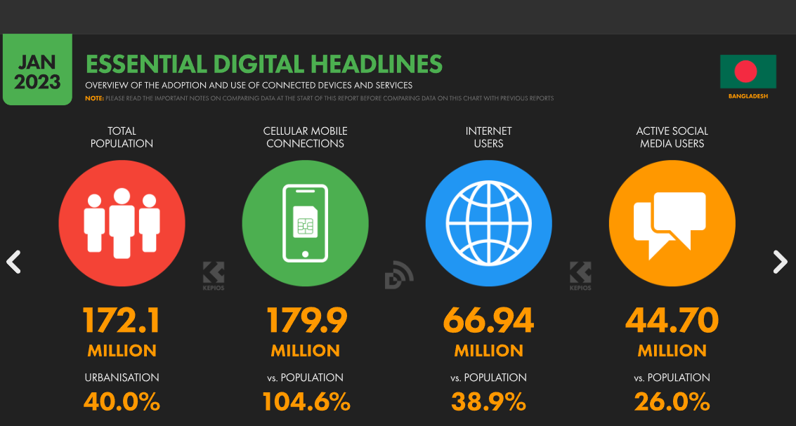
Source: Digital 2023: Bangladesh — DataReportal – Global Digital Insights
Today, it's important to note that many families in rural areas now have smartphones. GSMA Intelligence’s numbers indicate that mobile connections in Bangladesh were equivalent to 104.6 percent of the total population in January 2023 [1].
Proportion of households with a smart phone 59.9 in rural area and 73.5 in urban area. A higher proportion of used internet in urban area (68.6 per cent) compared to rural area (36.4 per cent) is observed. Also a higher proportion of used computer in urban area (20.4 per cent) compared to rural area (3.8 per cent) is observed. On the other hand, use of mobile phone was satisfactory both in male (93.2 per cent) and female (87.8 per cent) whereas in rural 89.8 per cent and in urban 92.7 per cent. [3].
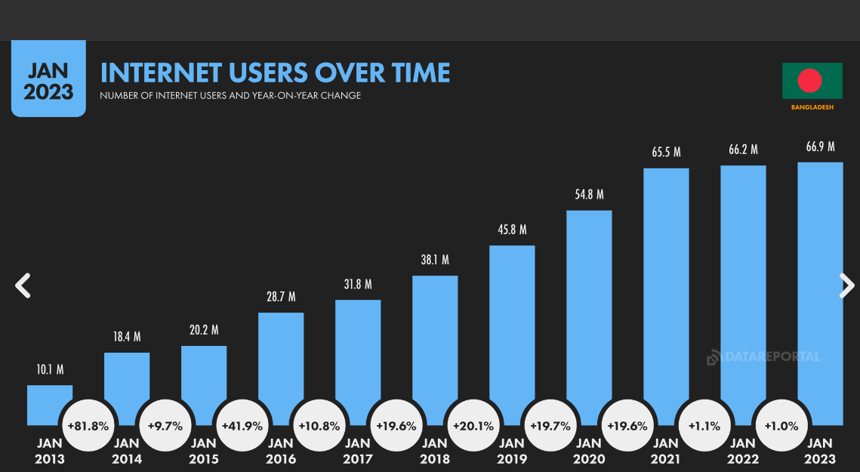Sources: Digital 2023: Bangladesh — DataReportal – Global Digital Insights
There were 66.94 million internet users in Bangladesh at the start of 2023, when internet penetration stood at 38.9 percent [1].
This means that people in rural areas are increasingly using smartphones, just like people in cities. This is a big deal because it makes our idea of creating a virtual e-learning app for students in rural areas even more practical. Since so many people in rural areas have smartphones, it's easier for them to access educational resources online. This is good news for our project because it means that we can provide quality education to students in rural areas through their smartphones. This aligns perfectly with Teach For Bangladesh's goal of making sure that every child, no matter where they live, gets a good education. By using smartphones, we can reach students in rural areas who might not have had the same educational opportunities before.

Features of our Virtual e-learning application:
- Virtual rooms: The application will feature virtual classrooms for where there will be virtual rooms for every subjects from spanning from class 6 to 12, including science, arts, and commerce. In each subject's virtual room, an extensive repository of resources related to their each chapters of their each subjects, including PDF books and solutions, video links, previous exam questions, and related content from platforms like Google and YouTube, and to remove further issues of network coverage and internet affordability, most of these contents will be readily stored for offline usage and regularly updated.
- Real-time interaction from anywhere at anytime: One of the key features of this application is the facility for real-time interaction among students. Whenever students encounter difficulties in their studies, they can connect with active users in these virtual rooms for collaborative problem-solving. Additionally, students will have the opportunity to share their own lectures and resources, fostering a collaborative and efficient learning environment. To promote healthy competition and motivation, the application will host weekly and daily basis examinations to prompt competition among them with exciting rewards such as books, mobile recharge, cash price etc. to encourage them to participate.
- Mental health concerns: By implementing this project, we aim to mitigate the geographical disparities in access to quality education. Students from rural areas will benefit from improved access to digital learning resources and the opportunity to engage with other users in meaningful ways. Through this solution, if there is any educational anxiety between students, they can join the virtual rooms anytime and share their problems with other active users and also study together which will also ease their mental health issues including their communicative and leadership skills. To enhance the learning experience, we also plan to integrate the guidance of qualified teachers into these virtual classrooms, ensuring comprehensive and effective learning for all.
- Reward based co-curriculum activities: This platform will also have a section for reward based co-curriculum activities like chess games, Sudoku, puzzles, mind games, art, poetry and musical competition and many more to engage students in diverse and enriching experiences beyond traditional academics. These activities not only foster creativity and critical thinking but also encourage students to explore their passions and talents. Through this engaging and interactive co-curricular section, we aim to promote well-rounded development and inspire a lifelong love for learning among students.
- Basic computer literacy: In addition to the aforementioned features, we also plan to incorporate basic computer literacy and learning modules within the platform. Recognizing the increasing importance of digital skills in today's world, these modules will empower students with essential computer skills, including typing, using office software, and internet safety. By equipping students with these fundamental digital competencies, we aim to prepare them for the challenges and opportunities of the digital age, ensuring their readiness for future academic and professional endeavors.
In summary, we aim to provide LEARN WITH FUN where we want to ensure overall education with enjoyment. We aim to make learning not only informative but also engaging and fun for all students, ensuring they have a positive and enriching educational journey.

Alignment of Project’s Goals and Objectives with Teach For Bangladesh:
- Expanding Access: Our e-learning app bridges gaps, offering quality education to rural students with smartphones, supporting Teach For Bangladesh's goal of equal opportunities.
- Equipping Students: Virtual classrooms provide real-time interaction, fostering critical thinking and communication skills, aligning with Teach For Bangladesh's holistic approach.
- Promoting Support: Our platform creates a supportive community, nurturing an inclusive educational environment, enhancing the overall learning experience.
- Mental Health: Addressing anxieties in our app aligns with holistic student development, contributing to well-rounded individuals.
- Co-curricular Engagement: Reward-based activities encourage creativity and critical thinking, complementing a well-rounded education.
- Digital Literacy: We prioritize digital skills, preparing students for the digital age, aligning with Teach For Bangladesh's recognition of digital literacy's importance.
- Teacher Integration: Experienced educators in virtual classrooms enhance the quality of education, aligning with Teach For Bangladesh's emphasis on exceptional educators.
The target audience
- Rural Students: These are students living in rural areas of Bangladesh who face educational disadvantages due to factors like geographical location, lack of qualified teachers, and limited resources.
- Urban Students: While the primary focus is on rural areas, the application is accessible to urban students as well, promoting equal educational opportunities.
- Students Struggling with Mental Health: The platform provides a space for students to address mental health and co-curricular concerns and educational anxieties, making it relevant for students facing such challenges.
- Physically Challenged Students: The application will also accommodate physically challenged students ensuring the platform is inclusive and accessible to all is a crucial goal.

Forecasted budget for the project
This is just an approximate budget in accordance to developing a large size software in Bangladesh.
Budget Categories | Approximate Budget (BDT)
Development Costs ( Project Size- Large)  - Software development  - Licensing fees  - Feature and Design | 4,50,000 BDT  50,000 BDT  2,00,000 BDT
Content Creation and Acquisition - Content creation  - Licensing fees for content | 1,50,000 BDT  30,000 BDT
Marketing and Promotion - Advertising and promotion | 50,000 BDT
Infrastructure and Technology  - Security measures | 20,000 BDT
Monitoring and Evaluation - Data collection and analysis  - Administrative and Overhead Costs | 30,000 BDT  10,000 BDT
Training and Capacity Building  - Teacher/facilitator training  - Student capacity-building | 30,000 BDT  30,000 BDT
Total Project Budget | 10,00,000 BDT

Probable Timeline

1. App Development – 3 to 4 Months
2. Awareness through seminar sessions or other ways among parents, students, teachers and community people – 1 year
3. Promotion - 4 to 5 months
4. Collaborating with Schools or local Officials – 6 Months
So our probable timeline is within 1 year.
After 1 year we think students will be benefitted from this initiative in a sustainable way and depending on the responses among students and funds we will upload more content and increase facilities within the app.

References:

Digital 2023: Bangladesh — DataReportal – Global Digital Insights [1]
https://www.tbsnews.net/bangladesh/telecom [2]
- - বাংলাদেশ পরিসংখ্যান ব্যুরো-গণপ্রজাতন্ত্রী বাংলাদেশ সরকার (bbs.gov.bd) [3]
https://www.risingbd.com/english/national/news/89318 [4]

